Concept: Project C

*Members:*

* Ciwan Clifford - 2315423
* Gregor Gräßner - 2315866
* Simón Hoyos Cadavid - 2319104

*Goal:*

The goal of the project is to create a short version of a turn-based RPG in order to get a closer look at aspects of game design beyond graphical design and programming. It is important to note that this previously mentioned aspect is the main characteristic of the project: the making of a deeply thought-out game. This game would also try to pay homage to the old RPGs of the late 1980s and 1990s like Final Fantasy.

*Concept:*

After a lot of thought, the students settled for the project being a demo[1] for a turn-based RPG (Role Playing Game) set in the world of Midgard, referring to the human world in Nordic mythology. Wanting to stage the game somewhere crueler that our own world, it was thought by the students that it will not only be based on Nordic mythology (which the students have had some experience with), but also take place during the Ragnarök, the twilight of the gods. This mythology was chosen because it has a large array of monsters and enemies which can be taken as inspiration for the ones in the game, and the set of the Ragnarök was appealing for a story of a man who is trying to survive.

The main task for the students will not be to push the technical capacities to a maximum or to make the best graphical systems possible, but the idea behind the project is to make the students dive into game design aspects such as:

* Storytelling.
* Quest design.
* Level design.
* World design.
* Backstory/ Lore
* Item design.
* Pixel art design.
* Etc.

In order to achieve this, the students will have to think out the different possibilities for all of these creating scripts, sketches and diagrams for a better understanding of the thought process made. It is important to note that this is all part of the project and will be of course shared with the professor when the project is finished.

*Graphical requirements:*

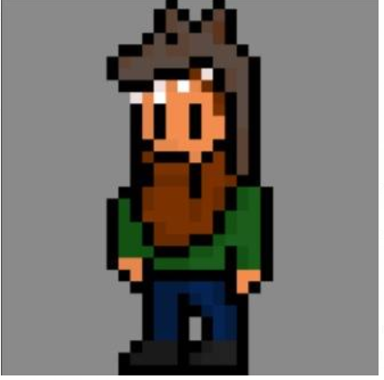Since the game is going to pay homage to old RPGs it was thought by the students that it should be done within a 32x32 pixel art style for the characters, and about double for the bosses, while having the world around 240x160 (Gameboy advance resolution). This is also the first approach for the students to pixel art graphics, but it will also be an important aspect that they would like to learn.

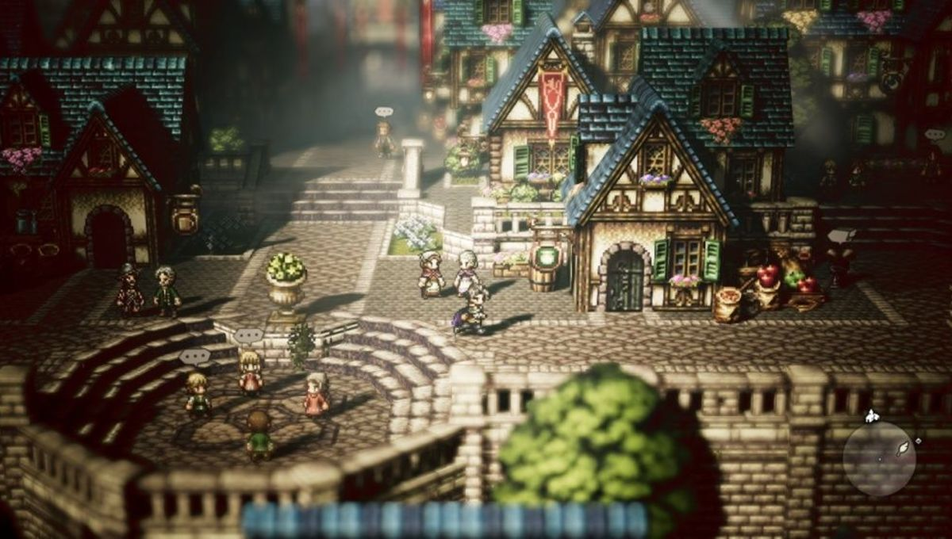It must also be explained that the world of the game is not going to be completely 2D, because the students will dive into the usage of 2.5D graphics. The aforementioned graphical setting is thought of as a world composed by sprites and textures (2D images), that wrap a 3D world, reminiscing of games like Paper Mario and Octopath Traveler. All of the characters and places are going to be represented by sprites, but the world itself is three dimensional, giving a feeling of depth. The reason behind this is to show a contrast between the old 2D RPG games, and the gaming world we now live in which has advanced so much, that it can mimic even our own three-dimensional real world.

Fig 1. First attempt for the main character.

Fig 2. Inspiration for the graphics.

*Technical requirements:*

The game is going to be made with the help of the Unity engine, utilizing the C# programming language. No tools for the creation of the sprites and textures have been set in stone, the options are still being decided.

*Workload distribution:*

|  |  |  |
| --- | --- | --- |
| Specialized job | Head | Secondary |
| Team Management | S | - |
| Sprite design | G | S |
| Texture design | G | S |
| Unity | C | S |
| Programming | C | S |
| Storytelling / Lore | S | C, G |
| Level Design | S | C |

* *C*: Ciwan Clifford.
* *G*: Gregor Gräßner.
* *S*: Simón Hoyos Cadavid

*Plot:*

**I am Ulf.**

I believe more than two years have passed since the beginning of this cruel winter, though I can’t know for sure. It has been becoming more problematic to follow time with each passing day when the sun being slowly dimmed by the jaws of Sköll. This land has been forsaken by the gods; abandoned while they relish in mead and gold, just waiting for the end to come… but I don’t trust the Aesir no more, I don’t trust the Vanir no more… I don’t trust anymore.

I do know what lies beyond, but I don’t intent to perish like the rest of my kind… no … I will **not** be sent to Helheim. I will **not** succumb to the desperation down under whilst Hela laughs on my face. **I will** open the doors of Valhalla and dance, and sing, and drink together with my brothers and sisters. I will survive this… so I toast for times to come, I toast for everyone I’ve lost, I toast… for me; for I am Ulf, son of Bodolf, and **I am alive**.

With these words begins the journey of our hero. Before the Ragnarök, a three-year winter called Finbul hit Midgard, killing most of life on earth as we know it. Our hero finds himself struggling for survival in a world without gods, in a world devoid of life, where only cold and death inhabit. Fighting against his own insanity, our hero embarks on a journey to reclaim what is rightfully his: the land. But he will have to be weary, because not only the world itself is confabulating against him… the twilight of the gods is approaching, and so are the dark forces who intent on destroying everything one holds dear…

*Call to adventure:*

The story begins with the hero Ulf, who is struggling to survive in a world struck by the Finbul winter, a three-year winter that precedes the Ragnarök. The problem with this is that it’s only a setting, and it’s not enough to kick off the *hero’s journey*. Consequently, the students started thinking what the possibilities for the *call to adventure* could be. For this reason, it was thought that the first push for the hero to jump to the main quest had to be *honor.* Nordic mythology is always set in a world where people have to achieve honor and glory in order to live in the equivalent place to heaven, in their case called Valhalla. They have to die in battle, having lived a long life as a honorable warrior.

Ulf was tricked by Loki, who was disguised as an old warlock, into losing his honor when Ulf and his crewmates tried to rob Loki thinking he was just an old man living in the forest. Loki made him kill all his mates and dumped him on a faraway coast. After a long time of regret and self-pity Ulf is decided to take back what was stolen some time ago and with this in mind, starts his journey of traveling around the world in order to find the man who took everything away from him, before the Ragnarök claims his honorless life.

*References:*

Krishna (2018). Octopath Traveler is the RPG Nintendo switch gamers have been waiting for. Image Retrieved from https://www.syfy.com/syfywire/octopath-traveler-is-the-rpg-nintendo-switch-gamers-have-been-waiting-for.

Wikipedia, the free encyclopedia (2019). Hero's journey. Retrieved from https://en.wikipedia.org/wiki/Hero%27s_journey.

1. The project will be a demo, which means not a complete game, but only a part of the game. This was decided because of the extreme time investment one would need in order to create a full RPG.